**Phase-5 Practice Project: Assisted Practice -**

**1.Install Kubernetes**

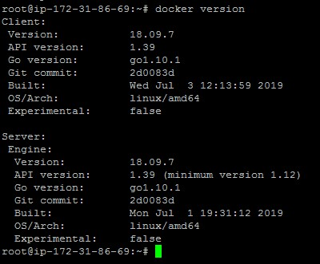

curl -s https://packages.cloud.google.com/apt/doc/apt-key.gpg | apt-key add - echo "deb http://apt.kubernetes.io/ kubernetes-xenial main"

>/etc/apt/sources.list.d/kubernetes.list apt-get update

apt-get install -y kubeletkubeadmkubectl

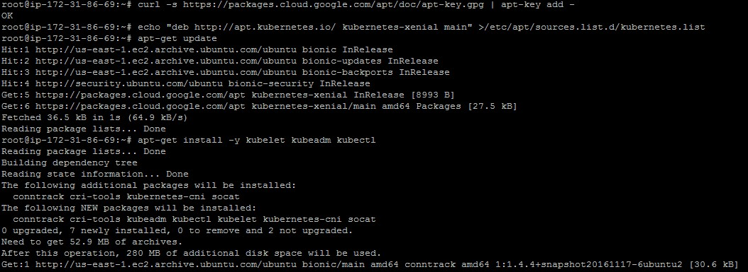

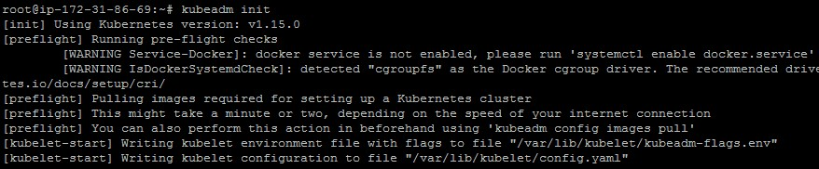

mkdir -p $HOME/.kube

sudo cp -i /etc/kubernetes/admin.conf $HOME/.kube/config sudochown $(id -u):$(id -g) $HOME/.kube/config

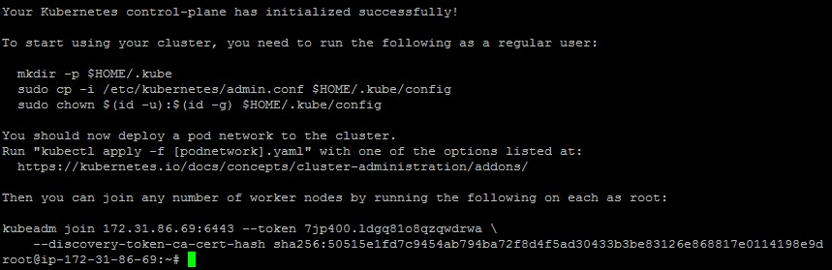

export kubever=$(kubectl version | base64 | tr -d '\n')

kubectl apply -f "https://cloud.weave.works/k8s/net?k8s-version=$kubever"

